**CASE STUDY MODEL OF ZARA CLOTHING**

**CASE STUDY MODEL :** Zara’s Unique Business Model is Driven by Its Supply Chain Capabilities.

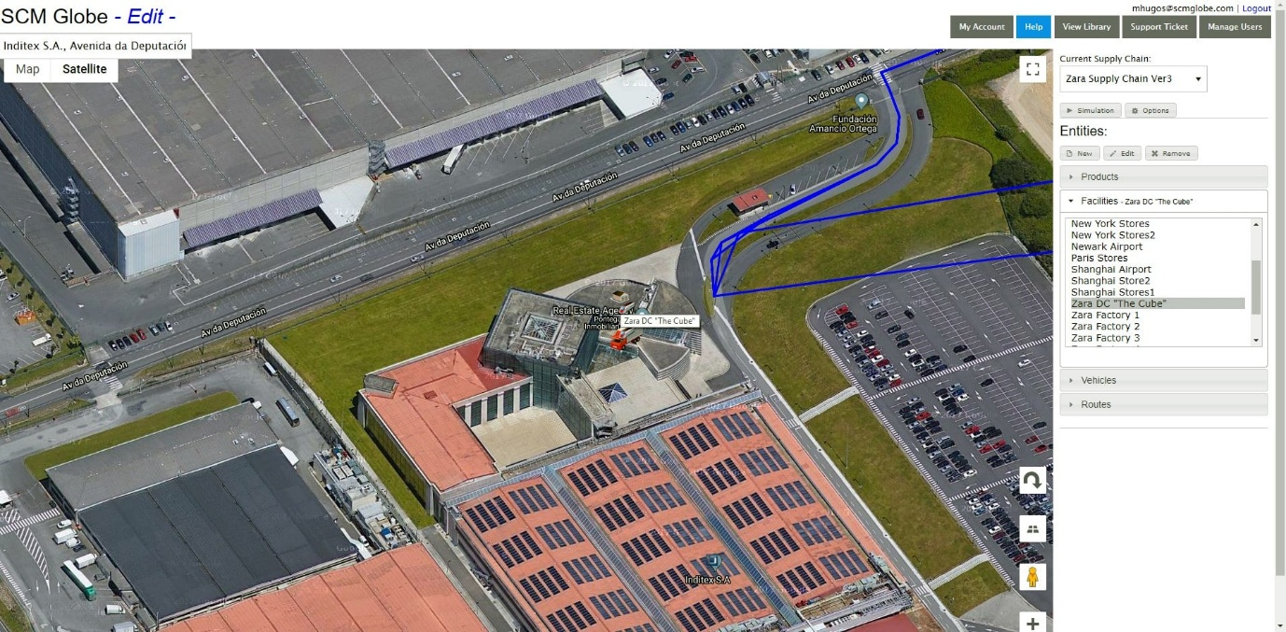Zara changes its clothing designs every two weeks on average, while competitors change their designs every two or three months. It carries about 11,000 distinct items per year in thousands of stores worldwide compared to competitors that carry 2,000 to 4,000 items per year in their stores. Zara’s highly responsive supply chain is central to its business success. The heart of the company and its supply chain is a huge, highly automated distribution center (DC) called “The Cube”. The screenshot below shows a closeup satellite view of this facility.

The company was founded in Spain in 1974 by Amancio Ortega and his wife Rosalía Mera. It is the flagship business unit of a holding company called Inditex Corporation with headquarters in Arteixo, Galicia, a city in northwestern Spain near where Mr. Ortega was born. In 2019 Zara was ranked as the [46th most valuable brand](https://www.forbes.com/companies/zara/#3d6b75537487) in the world by Forbes (see bibliography below).

### **Company Business Model**

Agents for the company are always scouting out new fashion trends at clubs and social gatherings. When they see inspiring examples they quickly send design sketches to the garment designers at the Cube. New items can be designed and out to the stores in 4 – 6 weeks, and existing items can be modified in 2 weeks.

The company’s core market is women 24 – 35 years old. They reach this market by locating their stores in town centers and places with high concentrations of women in this age range. Short production runs create scarcity of given designs and that generates a sense of urgency and reason to buy while supplies last. As a consequence, Zara does not have lots of excess inventory, nor does it need to do big mark-downs on its clothing items.

Zara has 12 inventory turns per year compared to 3 – 4 per year for competitors. Stores place orders twice a week and this drives factory scheduling. Such short term focused order cycles make forecasts very accurate, much more accurate than competitors who may order every two weeks or every month.

Clothing items are priced based on market demand, not on cost of manufacture. The short lead times for delivery of unique fashion items combined with short production runs enable Zara to offer customers more styles and choices, and yet still create a sense of urgency to buy because items often sell out quickly. And that particular item or style may not be available again after it sells out. Zara sells 85 percent of its items at full price compared to the industry average of selling only 60 percent of items at full price. Annually there is 10 percent of inventory unsold compared to industry averages of 17 – 20 percent.

In Spain customers visit Zara stores 17 times per year on average compared to 3 times per year for competitors. Because their clothing designs change often, it is harder for people to see them clearly on the Internet and thus they are encouraged to come into the stores instead and try on the unique fashions that Zara offers (screenshot below shows people at a Zara store in Madrid, Spain).

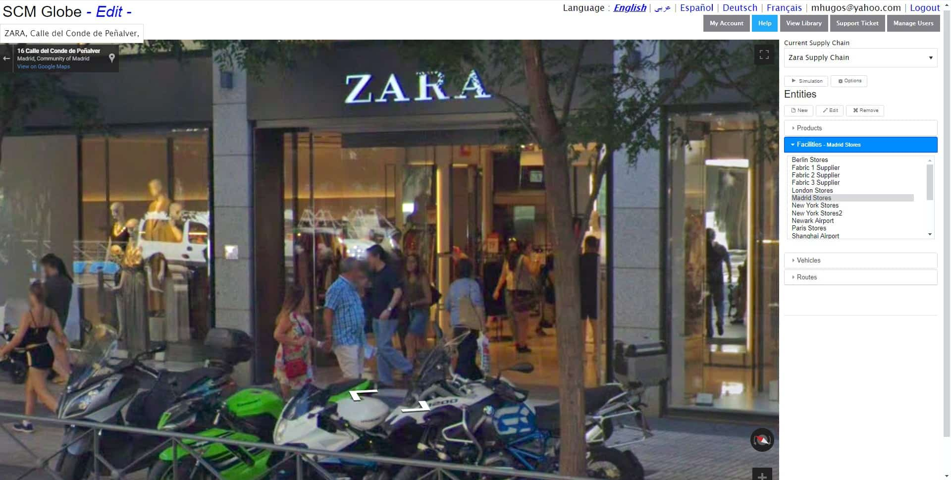

Zara spends its money on opening new stores instead of spending a lot on ad campaigns. Estimates vary on the number of Zara stores worldwide. An article in the New York Times Magazine (November 2012, “[How Zara Grew into the World’s Largest Fashion Retailer](https://www.nytimes.com/2012/11/11/magazine/how-zara-grew-into-the-worlds-largest-fashion-retailer.html?_r=0)” see reference in bibliography below), placed the store count at around 5,900. An article in Forbes simply states there are “more nearly 3,000 stores” (June 2019, “[The World’s Most Valuable Brands – #46 Zara](https://www.forbes.com/companies/zara/#3d6b75537487)“, see bibliography below). Annual sales for 2018 were [estimated by Forbes to be $21.3 billion](https://www.forbes.com/powerful-brands/list/#tab:rank). The holding company, Inditex SA, is a public company and [Inditex provides annual statements](https://www.inditex.com/investors/investor-relations/annual-reports" \t "_blank), but it does not break out Zara sales from sales of the other brands owned by Inditex (Pull&Bear, Massimo Dutti, Bershka, Stradivarius, Oysho, Zara Home and Uterqüe). Zara also uses a flexible business model where its stores can be owned, franchised or co-owned with partners. So it is not always possible to find exact numbers for Zara’s business operations and finances.

### **Manufacturing and Supply Chain Operations Make Zara Unique**

Zara buys large quantities of only a few types of fabric (just four or five types, but they can change from year to year), and does the garment design and related cutting and dyeing in-house. This way fabric manufacturers can make quick deliveries of bulk quantities of fabric directly to the Zara DC – the Cube. The company purchases raw fabric from suppliers in Italy, Spain, Portugal and Greece. And those suppliers deliver within 5 days of orders being placed. Inbound logistics from suppliers are mostly by truck.

The Cube is 464,500 square meters (5 million square feet), and highly automated with underground monorail links to 11 Zara-owned clothing factories within a 16 km (10 mile ) radius of the Cube. All raw materials pass through the Cube on their way to the clothing factories, and all finished goods also pass through on their way out to the stores. The diagram below illustrates Zara’s supply chain model.

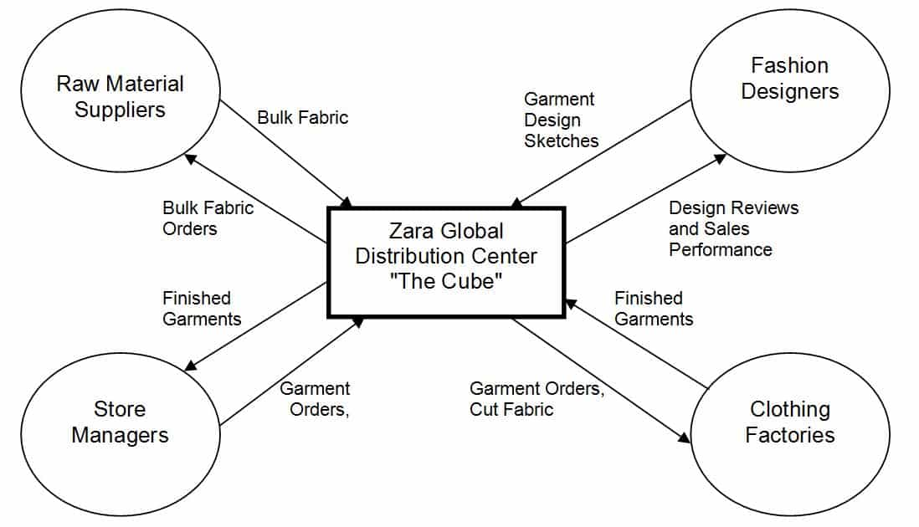Zara’s factories can quickly increase and decrease production rates, so there is less inventory in the supply chain and less need to finance that inventory with working capital. They do only 50 – 60 percent of their manufacturing in advance versus the 80 – 90 percent done by competitors. Zara does not need to place big bets on yearly fashion trends. They can make many smaller bets on short term trends that are easier to call correctly.

The Zara factories are connected to the Cube by underground tunnels with high speed monorails (about 200 kilometers or 124 miles of rails) to move cut fabric to these factories for dyeing and assembly into clothing items. The monorail system then returns finished products to the Cube for shipment to stores. Here are some facts about the company’s manufacturing operations:

* Zara competes on flexibility and agility instead of low cost and cheap labor. They employ about 3,000 workers in manufacturing operations in Spain at an average cost of 8.00 euros per hour compared to average labor cost in Asia of about 0.40 euros per hour.
* Zara factories in Spain use flexible manufacturing systems for quick change over operations.
* 50% of all items are manufactured in Spain
* 26% in the rest of Europe
* 24% in Asia and Africa

The screenshot below illustrates how the Zara supply chain is organized. Manufacturing is centered in northwestern Spain where company headquarters and the Cube are located. But for their main distribution and logistics hub they chose a more centrally located facility. That facility is located in Zaragoza in a large logistics hub developed by the Spanish government. Raw material is sent by suppliers to Zara’s manufacturing center. Then finished garments leave the Cube and are transported to the Zara logistics hub in Zaragoza. And from there they are delivered to stores around the world by truck and by plane.

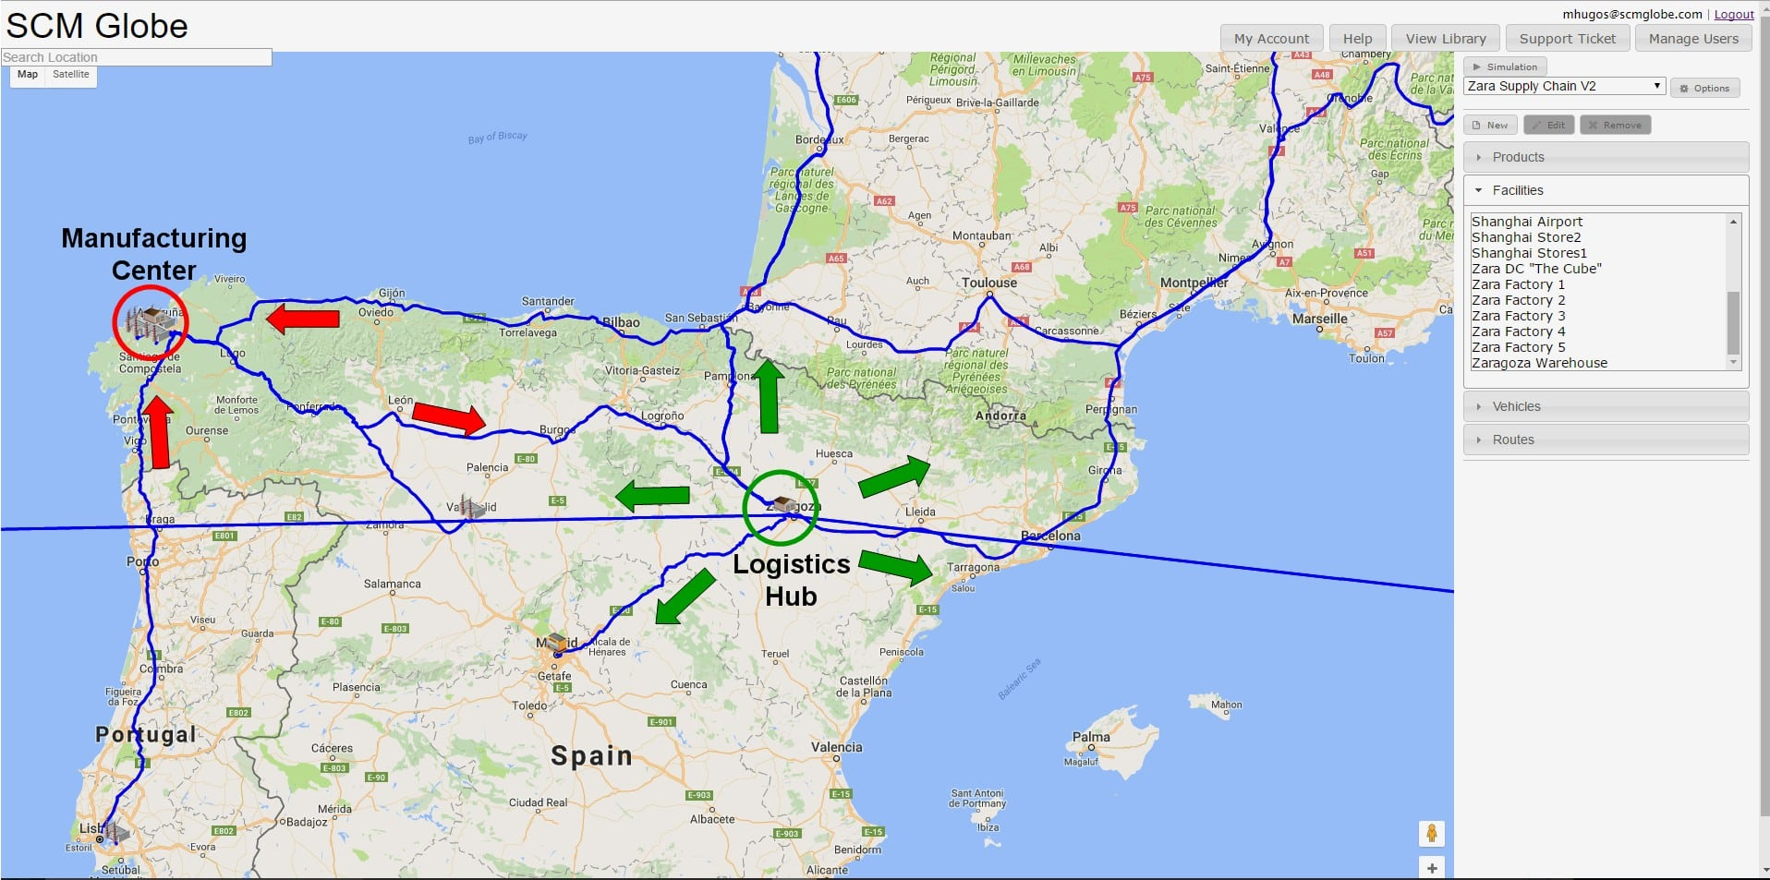

Zara can deliver garments to stores worldwide in just a few days: China – 48 hrs; Europe – 24 hrs; Japan – 72 hrs; United States – 48 hrs. It uses trucks to deliver to stores in Europe and uses air freight to ship clothes to other markets. Zara can afford this increased shipping cost because it does not need to do much discounting of clothes and it also does not spend much money on advertising.

### **A Lean and Agile Supply Chain**

Stores take deliveries twice per week, and they can get ordered inventory often within two days after placing their orders. Items are shipped and arrive at stores already on hangers and with tags and prices on them. So items come off delivery trucks and go directly onto the sales floor. This makes it possible for store managers to order and receive the products customers want when they want them, week by week.

Zara stores respond practically in real-time as styles and customer preferences evolve. It is a great business model for success in the high-change and hard to predict fashion industry. It means about half of the clothing the company sells, which includes most of its high margin and unique fashion items (but not its lower margin basic items), is manufactured based on highly accurate, short-term (2 – 6 week) demand forecasts. Because this business model tracks so closely to real customer demand from one month to the next, it frees the company to a large degree from getting caught in cyclical market ups and downs that ensnare its competitors (those cycles are driven by boom-to-bust gyrations generated by the [bullwhip effect](http://sloanreview.mit.edu/article/the-bullwhip-effect-in-supply-chains/)). Turbulence in the global economy since 2008 has hurt sales at many competing fashion retailers, but Zara has seen steady, profitable growth during this time.

A fast-moving and finely tuned supply chain like Zara’s requires constant attention to keep it running smoothly. Supply chain planners and managers are always watching customer demand and making adjustments to manufacturing and supply chain operations. The screenshot below shows the result of one simulation using the supply chain model outlined above. Continuous adjustments need to be made to production rates, vehicles, and delivery routes and schedules to keep this supply chain working well.

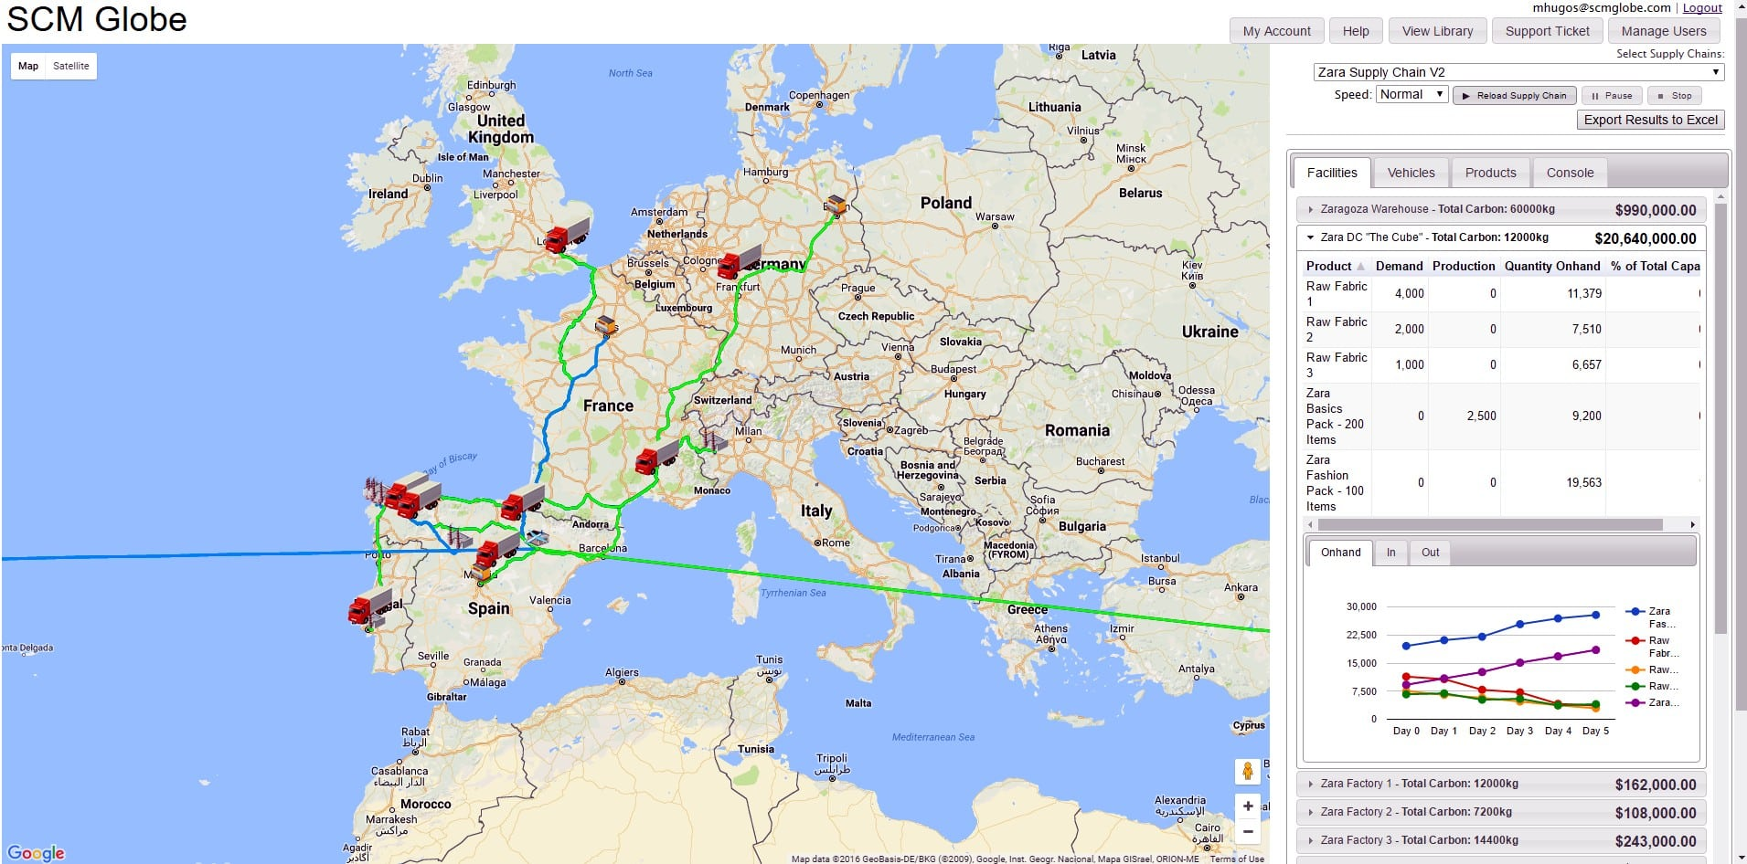

Zara is a clothing and fashion retailer that uses its supply chain to significantly change the way it operates in a very traditional industry. No other competitor can copy its business model until it first copies its supply chain. And since supply chains are composed of people, process, and technology, even the latest and greatest technology is not a competitive advantage all by itself. People must be well trained, and processes must be put in place that enable people to apply their training and their technology to best effect.

Buying technology similar to that used by Zara is easy. But for the technology to be used effectively, competitors must learn about the mental models and the operating procedures used by Zara. Good mental models enable people to understand the potentials and see the opportunities that a real-time supply chain offers. Effective operating procedures enable people to act on what they see and capitalize on the competitive advantages their technology gives them.

Zara has spent more than 30 years building its unique real-time supply chain and training its people. So competitors have a lot of learning to do to create the mental models, and roll out the operating procedures needed to do what Zara does so well.

**ZARA SUPPLY CHAIN REPORTING TEMPLATE:**

Import your simulation data into this template to create **15-DAY P&L REPORTS** and key performance indicators.  Zara’s agile supply chain enables it to use shorter planning cycles (15-days instead of 30-days). The reporting template is designed for use with the supply chain model in the online library titled “Zara Clothing Company Ver4”.  If you add more products, facilities, or vehicles to the model you will need to expand the spreadsheet to accommodate those additions. A sample P&L report created from simulation data is shown below:

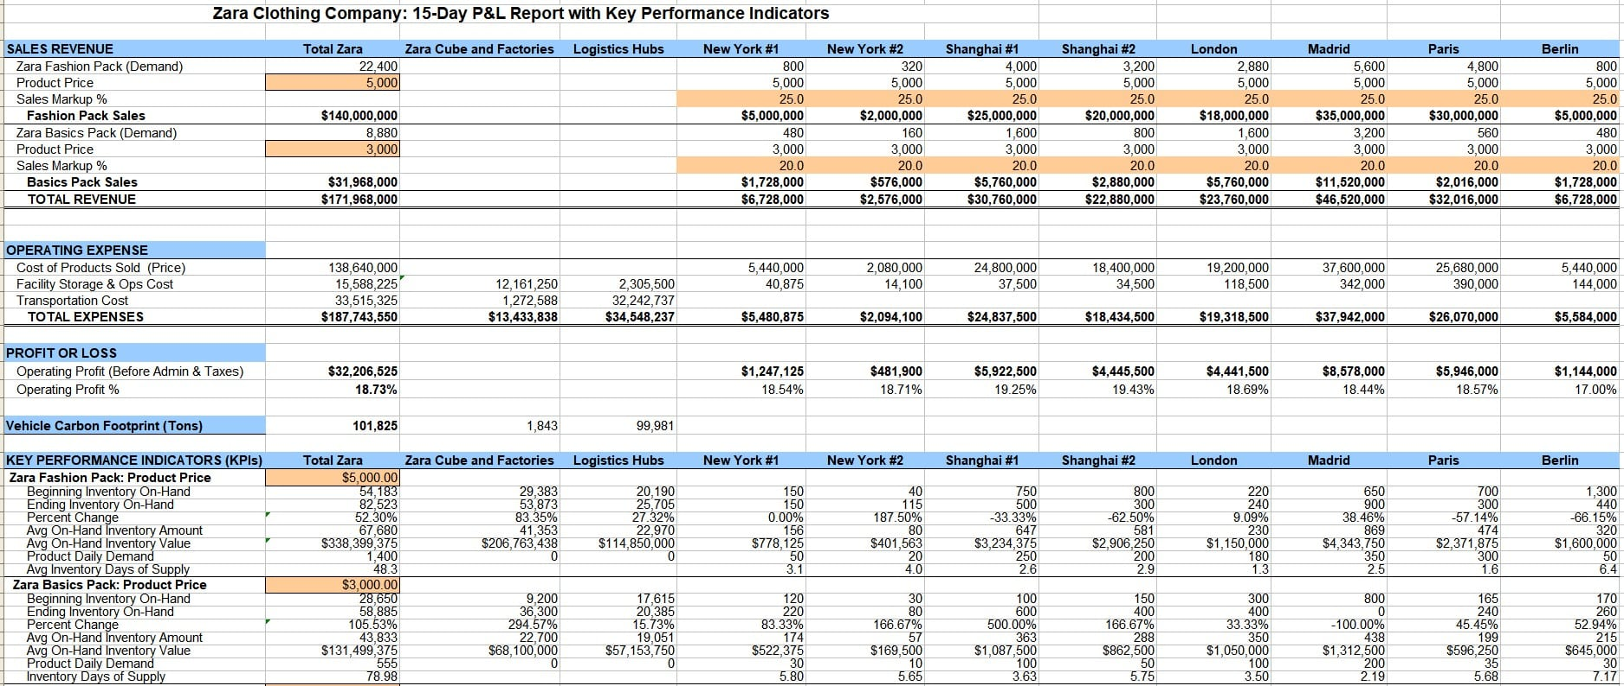

***CREATE AN EXECUTIVE BRIEFING*** — a 3 to 5 page report or a short deck of presentation slides. Use screenshots and data produced by simulations to illustrate what you learned about how the Zara supply chain operates. Explain what were the main problems you encountered in getting your simulation to run for 15+ days. Show what you did to address those problems. Present the three or four main things you learned about this supply chain. Explain why these things make this supply chain such a competitive advantage for Zara.

### **Assumptions and Simplifications Used in this Model**

Because Zara operations and financial reporting is combined with the other retail brands owned by Inditex, specific details of the Zara business model and supply chain can be difficult to verify. Yet the supply chain model presented here is still a useful picture of the Zara supply chain and illustrates its operations and its capabilities (see more about this in “[**Supply Chain Modeling and Simulation Logic**](https://www.scmglobe.com/online-guide/supply-chain-modeling-simulation-logic/)“). This case study and supply chain model is based on data from articles listed in the bibliography below. The assumptions and specifications listed here are built into the model, and **you can easily change them as better data becomes available**. New products, facilities, vehicles and routes can also be added to this model to further explore how Zara’s supply chain operates.

* Zara finished goods garments are combined into two categories of products, Zara Fashion Pack represents in-house manufactured high fashion items, Zara Basics Pack represents basic items contract manufactured by others
* Zara Fashion Pack = 100 garments; price of 5,000 euros; weight of 40 Kg; volume of 1 cubic meter;
* Zara Basics Pack = 200 garments; price of 3,000 euros; weight of 60 Kg; volume of 0.5 cubic meters
* The Cube employs 3,000 people at average rate of 8 euros per hour = 64 euros per day
* Automated warehouse in Zaragoza employs 800 people at avg of 64 euros per day and other facility operating costs for utilities, insurance, etc. cost additional 15,000 euros daily
* Raw fabric costs per case: Fabric 1 = 1 cubic meter; price of 1,000 euros; Fabric 2 = 0.5 cubic meter; price of 800 euros; Fabric 3 = 0.6 cubic meter, price of 1,200 euros
* Zara factories need mix of raw fabrics to create their finished goods; see the definition of these facilities to see individual requirements and production
* The Cube has 1.6 million cubic meters of product storage space
* 150 million items pass through Cube annually or 411,000 per day
* 11 actual Zara factories are represented by 5 factories in the model
* Monorail shipping containers are 50 cubic meters in volume, can carry 10,000 kilograms of weight, and travel at average speed including loading and unloading of 60 kilometers per hour
* Zara stores in a single city are represented by a single store that combines the demand of all stores in that city – not all cities are included and more cities can be added to this model
* Vehicle operating costs per km are set to be just half the normal cost for trucks and airplanes. This more accurately models the process where Zara pays for one-way shipping containers to move products from one facility to another without paying the full round-trip cost (carbon per km was also adjusted to half of normal for the same reason). This compensates for the model logic which calculates vehicle costs based on the round trip distance instead of the one-way distance.
* Full operating cost per km is used for the monorail vehicles that move products between the Cube DC and the Zara garment factories because Zara owns those vehicles and pays for full round-trip costs.
* All specifications for Products, Facilities, Vehicles and Routes in this supply chain model can be edited and changed if you have better data.
* New products, facilities, vehicles and routes can be added to this model and you can simulate the results as you expand your model.